RESTRICTIONS FOR OPENING BANKING CURRENT ACCOUNTS TO PHISIC FOREIGNER PEOPLE IN BRAZIL WITHOUT PERMANENT OR TEMPORARY VISAS – REFLECTIONS TO THE REAL ESTATE ACQUISITION

Pedro Jackson Melo Colares

Abstract

The difficulties in opening Bank current accounts in Brazil for foreigners without temporary or permanents visas, which are represented by the foreigner card – RNE (National Register of Foreigners), are the focus of this article. The aim of this study is demonstrate that restrictions imposed to foreigners do not have juridical basement and that such attitudes are arbitraries and hurt particularly the right of equality between Brazilians and foreigners. For attainment of the aim mentioned, it was analyzed the legislative framework about this subject, the Central Bank of Brazil – BACEN resolutions, the doctrine related to rights of equality between Brazilians and foreigners, the role of public utility exercised by Banks and, in addition, it gathers a consultation effectuated directly in Central Bank about this subject, as well as examples of treatments given to foreigners in other countries in relation to opening accounts. During the work, it outlined the difficulties faced by foreigners for acquisition of real estate and services, and, in the end, it was examined the negatives impacts of such limitation in Brazilian Real estate Market. As result, it realized that Brazilian Banks attitudes are certainly arbitraries and illegal and that such restrictions bring harm for foreigners and national economy, leaving clear the need to change the reality through actions of the various sectors of society on organized and energetic way.

Key words: Opening. Account. Foreigners. Real Estate Market.

Resumo

As dificuldades de abertura de contas correntes para estrangeiros no Brasil sem vistos temporários ou permanentes, representados pela carteira de estrangeiro – RNE (Registro Nacional de Estrangeiros), são o foco deste artigo. O objetivo do estudo é demonstrar que as restrições impostas aos estrangeiros não possuem sustentáculo jurídico e que tais atitudes são arbitrárias e ferem sobremaneira o direito de igualdade entre brasileiros e estrangeiros. Para consecução do objetivo retro mencionado, foram analisados o arcabouço legislativo sobre o assunto, as resoluções do Banco Central do Brasil - BACEN, a doutrina referente a igualdade de direitos entre brasileiros e estrangeiros, o papel da utilidade pública exercido pelos bancos e, ainda, trouxe-se à colação uma consulta efetivada diretamente ao Banco Central sobre o assunto, bem como exemplos de tratamentos dispensados aos estrangeiros em outros países com relação à abertura de contas. No decorrer do trabalho, traçaram-se alguns aspectos das dificuldades enfrentadas pelos estrangeiros para aquisição de imóveis e de serviços, e, ao final, examinaram-se os impactos negativos dessas limitações no mercado imobiliário brasileiro. Como resultado, constatou-se que realmente é arbitrária e ilegal a atitude dos bancos brasileiros e que tais restrições trazem prejuízos aos estrangeiros e à economia nacional, restando nítida a necessidade de mudança dessa realidade através de ações dos diversos setores da sociedade de forma organizada e enérgica.

Palavras - chave: Abertura. Conta. Estrangeiros. Mercado imobiliário.

Introduction

There are many foreigners who came to Brazil to acquire real estate as “second home”, who do not want, in that moment, and do not wish, in near future, to live in this country. As supplements of real estate acquisition, the national from other countries acquire also furniture, house utensils, and services, among others. There are also those who only acquire real estate for effectuating investments, targeting profits in the medium and long term.

One of the first difficulties faced by foreign individuals who want to acquire real estate in Brazil is the bureaucracy surrounding the opening of current accounts, because foreigners are limited if they do not have temporary or permanent visas in the country, represented by the National Register of Foreigners – RNE. This procedure involves the private Banks, as well as those with public participation.

Such barrier prevents several transactions, because the purchasing power of these foreigners is completely limited in national territory, it is the reason they can not make transfer to a current or savings account, issue checks, make direct debits, among others, simple banking operations which has the aim of managing better their businesses, allowing foreigners acquire real estate and services in a more practical way, this means, making circulate wealth in Brazil easily.

The situation under exam is very much relevant to the Nation, because it is about a large amount of foreign capital which could has been invested by individuals, a fact which would make possible an increment in Brazilian economy.

This study aims to analyze the legal issues involving the relationship between foreigners in national territory and Bank institutions, examining specifically the impossibility of opening current accounts for the aforementioned aliens. It brings to glow the Brazilian laws which deals with the matter, the position of Central Bank of Brazil - BACEN in face of this subject, through the consulting carried out directly in the branch, as well as the doctrine which concerns about law of equality between Brazilians and foreigners, and, furthermore, the role of public utility which exercises the Brazilian Banks. It gathers, also, the treatment given to this subject for other countries.

In the development of this work, it outlined some of the difficulties faced by foreigners to purchase real estate, furniture and services in Brazil and, in the end, tried to measure, so at least shallowly, the negative impacts in national real estate market in face of the limitations presented. It is therefore clear that the restrictions imposed to foreigners who do not have juridical support, being just arbitrary attitudes that face the right of equality between Brazilian and foreigners.

1 The acquisition of real estate, furniture and services by foreigners in Brazil

With globalization, the flow of foreigners in Brazil increased abruptly, they came with their resources and the need for practice of acts that Brazilians carry daily.

One of the activities that the foreigners practice in Brazil is the acquisition of real estate and their supplements, such as the purchase of furniture for the residence, the hiring of engineers, architects, among others, these acts involving the handling of sums.

In the absence of current account of foreign ownership, the entry of capital for payment of such real estate and services by individual in a simple way is done in the following ways: carry the values in cash, checks and traveler's checks when traveling to Brazil or remittance of the values directly to sellers or service providers in Brazil, through direct bank transfer to accounts designated by the contractors in the national territory.

There are many problems involving the above methods of entering the capital in the country, and, contractually, there are several practical mishaps for effectuate the payment of real estate and services and obtain the discharge of the payment.

For instance, it could be highlighted one of the difficulties encountered with respect to transfers of amounts for payment of real estate in Brazil. It is clear that the contracts in the national territory can only be made with prices in real (article 318 of the Brazilian Civil Code). As the transfer is from the outside, it shall be subject to exchange rate and, depending on the volatility, the capital sent for payment could suffer very or little fluctuation, this means, the capital entered the country could be higher or lower than the price actually set in contract, causing therefore enormous difficulties for contractors who are in front of a great legal uncertainty when dealing with transactions of huge amount.

In another situation, imagine a foreigner carrying US$ 100,000 (one hundred thousand U.S. dollars), when he entered the country, to purchase a real estate in Brazil. First, he would have to declare the carry of values, and then he would walk on the unsafe streets in the national territory with high values, being subject to the action of criminals. It realizes that this hypothetical situation could be nonsense; however it often happens in the face of the difficulties that foreigners have to obtain accounts for deposits in Brazil.

2 Opening of accounts for foreigners without permanent or temporary visas. Applicable legislation. Opinion of Central Bank of Brazil.

The above mentioned problems simply disappeared with the possibility of opening accounts for foreigners without RNE, therefore this would allow the entry of capital through transfer of their assets from the current account to their current account in the country, so foreigners can hold all their transactions through drawings or emissions checks in Brazil, facilitating considerably the life of the alien in national territory, making circulate much more wealth.

On the other hand, Brazilian banks insist on not wanting to open such accounts for these foreigners, arguing, in essence, that conform to the standards issued by the Central Bank of Brazil.

However, in a study of the specific legislation that deals with this matter, which are CMN Resolution 2.025 of 1993, as amended by Resolution CMN 2.747 of 2000 and 2.953, of 2002, it did not see any prohibition on opening of current or savings accounts for foreigners who do not have the RNE, showing therefore that the banks do not make up for this activity because they fell free of this responsibility. To better base the research, it was made a consultation in responsible branch of the Central Bank of Brazil, and in response, it was confirmed the absence of any prohibition to open accounts for foreigners without RNE, which stands out the following words:

There is not, in that regulation, requirement of a specific type of identification document for the opening of accounts for deposits, financial institutions are free to define, by their own responsibility, the documentation to be requested from its customers. Thus, the presentation of the RNE is a requirement of the financial institution and not the Central Bank.

In order to solve the doubts about it, the Central Bank of Brazil met with the Association for Real Estate and Tourism Development in Northeast - ADIT NORDESTE, when it was stressed and decided the following:

Opening of current account - According to BC, there are no restrictions for opening current account in Brazil for foreigners. Any problem in this direction is a single decision of banks. The BC committed to discussing the matter with the Brazilian Federation of Banks (Febraban), as similar complaints are made by other economic sectors.

As it can see, there is not the alleged prohibition, leaving to the discretion of banks to set the rules for opening accounts for foreigners in the country, provided that compliance with the legal dictates. However, the rule of RNE presentation for opening of such accounts emerges clearly illegal, arbitrary and unconstitutional as it could see below.

3 Arbitrariness of banking institutions conduct, discrimination against foreigners. Need to respect the rights of equality between Brazilian and foreigners scribed the constitutional rules, below constitutional standards and international treaties. Role of public utility exercised by banking institutions. Possibility of opening of accounts in other countries by foreigner non-residents.

Touches clear in national legal framework the various standards that make differences between Brazilians and foreigners, such as those which concern to the acquisition of rural land, control of companies in some branches, application for public exams, application for elective positions, among others. However, such restrictions are specifics and everything that is not forbidden to foreigners is allowed in equality with the Brazilians, this is the analysis shows of, even superficial, the various Brazilian legal standards.

In Brazil, since the Republican Constitution of 1891 provides up to Brazilians and foreigners equal rights, "unfortunately, the prejudice of race, color, religion, social condition, etc. is widespread in all countries, both in relation to foreign as against its own nationals." (MELO, 2001).

Emerge sighted, therefore, the arbitrary and discriminatory character of the conduct of banks when they prohibit the access of foreigners referred to a bank account, because they go on the opposite way to several texts contained in national and international acts, such as Article 5, caput and incise II of the Federal Constitution, Article 2 of the Declaration of Human Rights, Articles 1 and 2 of the Bustamante Code, Article 5 of the Havana Convention on Rights of Foreigners, Article 2 of the International Covenant on Economic, Social and Cultural Rights concluded in New York, Articles 2 and 26 of the International Covenant on Civil and Political Rights inscribe in New York, and Article 1 of the American Convention on Human Rights, in San José, Costa Rica. (DOLINGER, 2001). It is recognized, therefore, to foreigners the following rights:

1) the human rights, or individual, that is, individual freedom and inviolability of the human person, with all resulting consequences, such as freedom of conscience, of worship, the inviolability of the home, the right to trade, the right to property, etc. 2) civil rights and family. (ACCIOLY, 1991).

Note that there is no rule barring the opening of accounts for foreigners without RNE, and if foreigners enjoy the same equality and civil rights as Brazilians, respecting the restrictions imposed by law, any attitude of financial institutions to limit access to this service is purely arbitrary and discriminatory going against the whole legal framework above ventilated, which closes on itself to equality between Brazilians and foreigners, therefore for the Brazilian is only required to complete qualification, any document of identification and the CPF (Resolution 2025 of Central Bank of Brazil).

For the foreigner, it could be presented the passport, driver's license, identity card, among others, as an identification document, adding logically CPF and qualification. However for Banks the cited documents are not enough, then they require the submission of the RNE, document that foreigners hardly ever have, treating, therefore, on completely different way the foreigners, injuring until the death the principle of equality.

In addition to the matters outlined before, it is appropriate to emphasize that financial institutions, whether private or public, have a role as a public utility within the Brazilian society, so they simply can not make decisions or create rules that affect Brazilian or foreigners, under any reason, without the approval of the government constituted.

Banking institutions are branches which receive delegation from public power to carry out activities that involve all society, including foreigners, so it ought not to have discrimination in relation to these. It should take into consideration the public munus performed by such institutions, which have as obligation provide services with quality and can not extract by forceps the foreigners rights through administrative acts that do not keep inside themselves any meaning.

Banks, which perform important social role, so much so that they are helped by governments in times of crisis and with public money, can not fail to perform the acts delegated to them, under penalty of plaster the flow of capital and bring huge harms to the domestic economy. For demonstrating that the requirements implemented by Brazilian banks are not in line with the thinking of the globalize economy, it takes as an example of bank openings for foreigners without temporary or permanent visas Spain , Japan and Switzerland, countries where there is incentive for entry of foreigner capital in banks institutions.

In Spain, there is not necessary that the foreigner live in the country, it is enough that he has a good working capital to invest in that nation. In Japan, there is a small restriction, the foreigner have to remain in Japanese territory for more than ninety days, because only thus will be entitled him to register in the city where he is and to open accounts in banks. In Switzerland, in its turn, what is required is a minimum value for the entry of capital, excluding this, the opening of the account can be held up by post.

The examples above show that Brazil does not need to follow a hard line to protect the economy. Away from the line of Keynian thought, it is possible that the country adopt small restrictions, but these can not affect substantially the entry of foreign capital, which happens, primarily, through the opening of accounts for deposits in banks located in national territory.

The BACEN, which is the branch responsible for registering the entry and exit of foreign capital in Brazil, has no specific statistics about the entry of capital in the country resulted by the transfer of assets from individuals to individuals, nor the entry of capital to purchase properties and to hire services. However, it is known that this flow is considerable, because there is a great number of foreigners who buy real estates for second home, especially in the Brazilian Northeast, which is intensifying others relations of consumption. Meanwhile, this flow could be much higher with the acts suggested above, but always with the government control to prevent crimes of escaping of foreign currency or other financial illicits, like what has been done with the direct investments made by foreigners in Brazilian companies (Foreign Direct Investment - IED), which has a incisive monitoring of BACEN.

Conclusion

In fact, the difficulties of foreigners who wish to trade in Brazil expand, it could be for rules which limit the access to certain rights, or for discrimination and arbitrariness performed by several institutions, among them the Brazilian banks.

There are no rules to prevent the opening of accounts for deposits by foreign without RNE, the negative of providing this kind of service to the alien results in a totally illegal.

As reflex of this attitude, it could conclude that such limitations lead to a juridical insecurity, which reduces, as consequence, the flow of foreign capital in the country, damaging not only the real estate market, but the various sectors of the Brazilian economy.

The society organized, through chambers of commerce with Brazilian and foreign representations in Brazil, especially Brazil-Portugal Chamber of Commerce Industry and Tourism, one of the most active of the country, the associations, such as the Agency for Real Estate and Tourism Development in Northeast - ADIT, the International Centers of Business, entrepreneurs, individual professionals, among others, together with state and local governments should establish channels of communication with FEBRABAN and BACEN to the difficult situation above can be changed urgently.

References

ACCIOLY, Hildebrando. Manual de Direito Internacional Público. 11. ed. São Paulo: Saraiva, 1991.

BAPTISTA, Luiz Olavo. Investimentos Internacionais no Direito Comparado e Brasileiro. Porto Alegre: Livraria do Advogado, 1998. (Coleção Direito e Comércio Internacional).
BRASIL. Ministério das Relações Exteriores do Brasil. Divisão de Atos Internacionais. Disponível em: <http://www2.mre.gov.br/dai/bustamante.htm>. Acesso em: 25 jan. 2009.

CIDADE VIRTUAL. REFWORLD Instrumentos Internacionais. Disponível em: <http://www.cidadevirtual.pt/acnur/refworld/refworld/legal/instrume/detent/civpot_p.htm>. Acesso em: 25 jan. 2009.

DOLINGER, Jacob. Direito Internacional Privado: Parte geral. 6. ed. Rio de Janeiro: Renovar, 2001.

MELO, Luis Gonzaga. Introdução ao Estudo do Direito Internacional Privado. São Paulo: EDUEP; WVC, 2001.

MY SWISS ADVISER. Abertura por Correspondência de Conta Bancária na Suíça. Disponível em: <http://www.myswissadviser.com/pt/mandat_PRO.htm>. Acesso em: 21 jan. 2009.

PINTO, Luis de Toledo; WINDT, M.C. Vaz dos Santos; CÉSPEDES, Livia. Vade Mecum. 6. ed. São Paulo: Saraiva, 2008.

PORTAL ESPAÑOL DE MOVILIDAD PARA INVESTIGADORES. Guia Práctica para Investigadores Extranjeros em España. Disponível em: <http://www.eracareers.es/fecyt/guia2008/cap15.jsp>. Acesso em: 22 jan. 2009.

POUPANÇA Bancária e remessa. Guia de Estrangeiro. Disponível em: <http://www.ia-ibaraki.or.jp/kokusai/portugal/life/guide/03-03.html>. Acesso em: 21 jan. 2009.

PROPERTY Community. When a non-resident sells Brazilian real estate to another non-resident the payment could take place outside Brazil. Disponível em: <http://www.propertycommunity.com/forum/brazil-property/4657-couple-musts-mustnots-when-investing-brazil-19.html>. Acesso em: 23 jan. 2009.

RECHSTEINER, Beat Walter. Direito Internacional Privado: Teoria e prática. São Paulo: Saraiva, 1996.

SÃO PAULO. Biblioteca Virtual de Direitos Humanos da Universidade de São Paulo. Disponível em: <http://www.direitoshumanos.usp.br/counter/Onu/Sist_glob_trat/texto/texto_2.html>. Acesso em: 25 jan. 2009.

______. Procuradoria Geral do Estado de São Paulo. Tratado Internacional. Disponível em: <http://www.pge.sp.gov.br/centrodeestudos/bibliotecavirtual/instrumentos/sanjose.htm>. Acesso em: 25 jan. 2009.

SILVEIRA, Eduardo Teixeira. A Disciplina jurídica do Investimento Estrangeiro no Brasil e no Direito Internacional. São Paulo: Juarez de Oliveira, 2002.

SPAIN BUSSINESS. Normas sobre Controle de Câmbio. Disponível em: <http://www.spainbusiness.pt/icex/cda/controller/pageInvBrasil/0,5274,31361682_32227355_38103284_0,00.html>. Acesso em: 20 jan. 2009.

ANEXXED 1

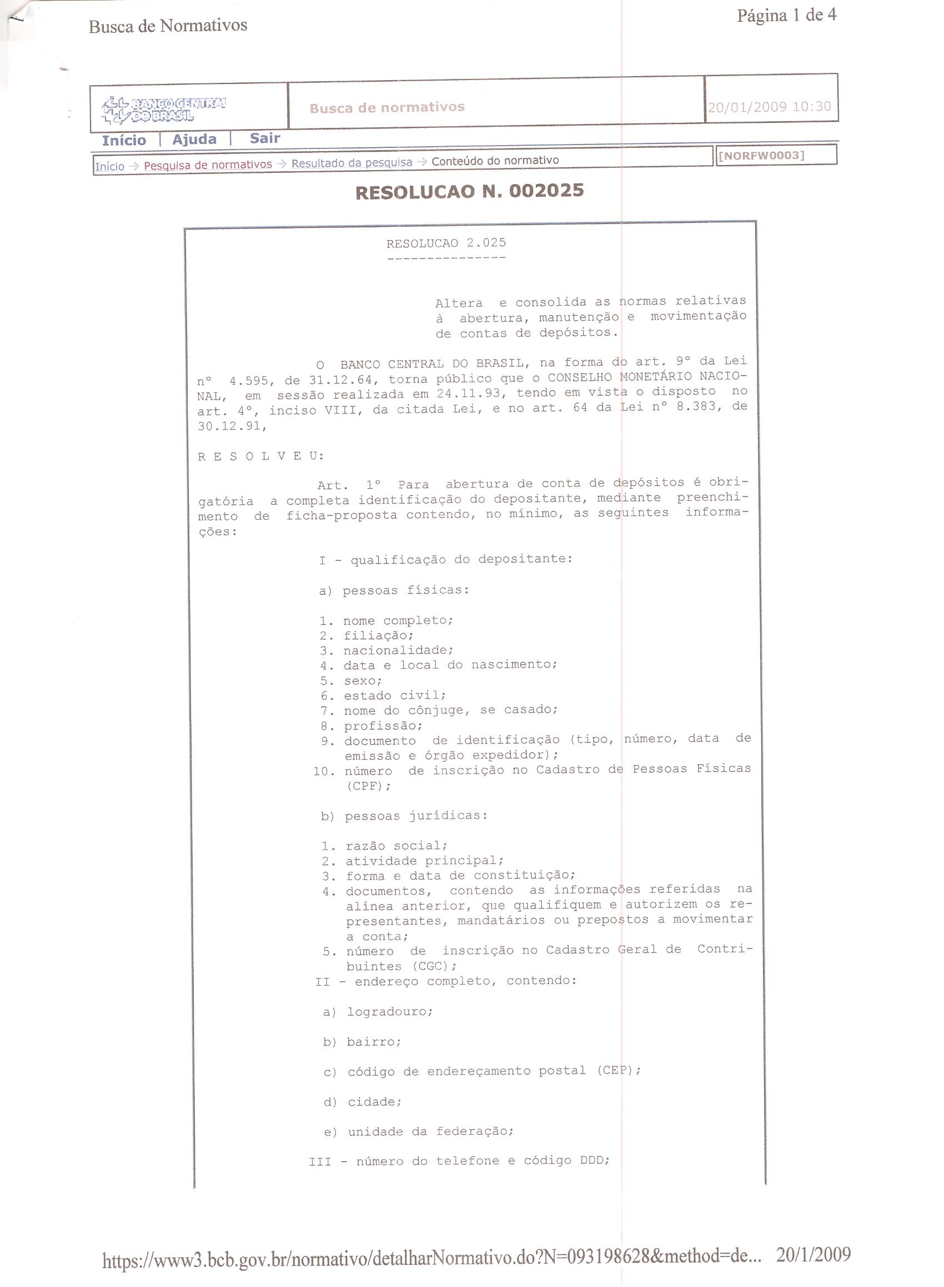

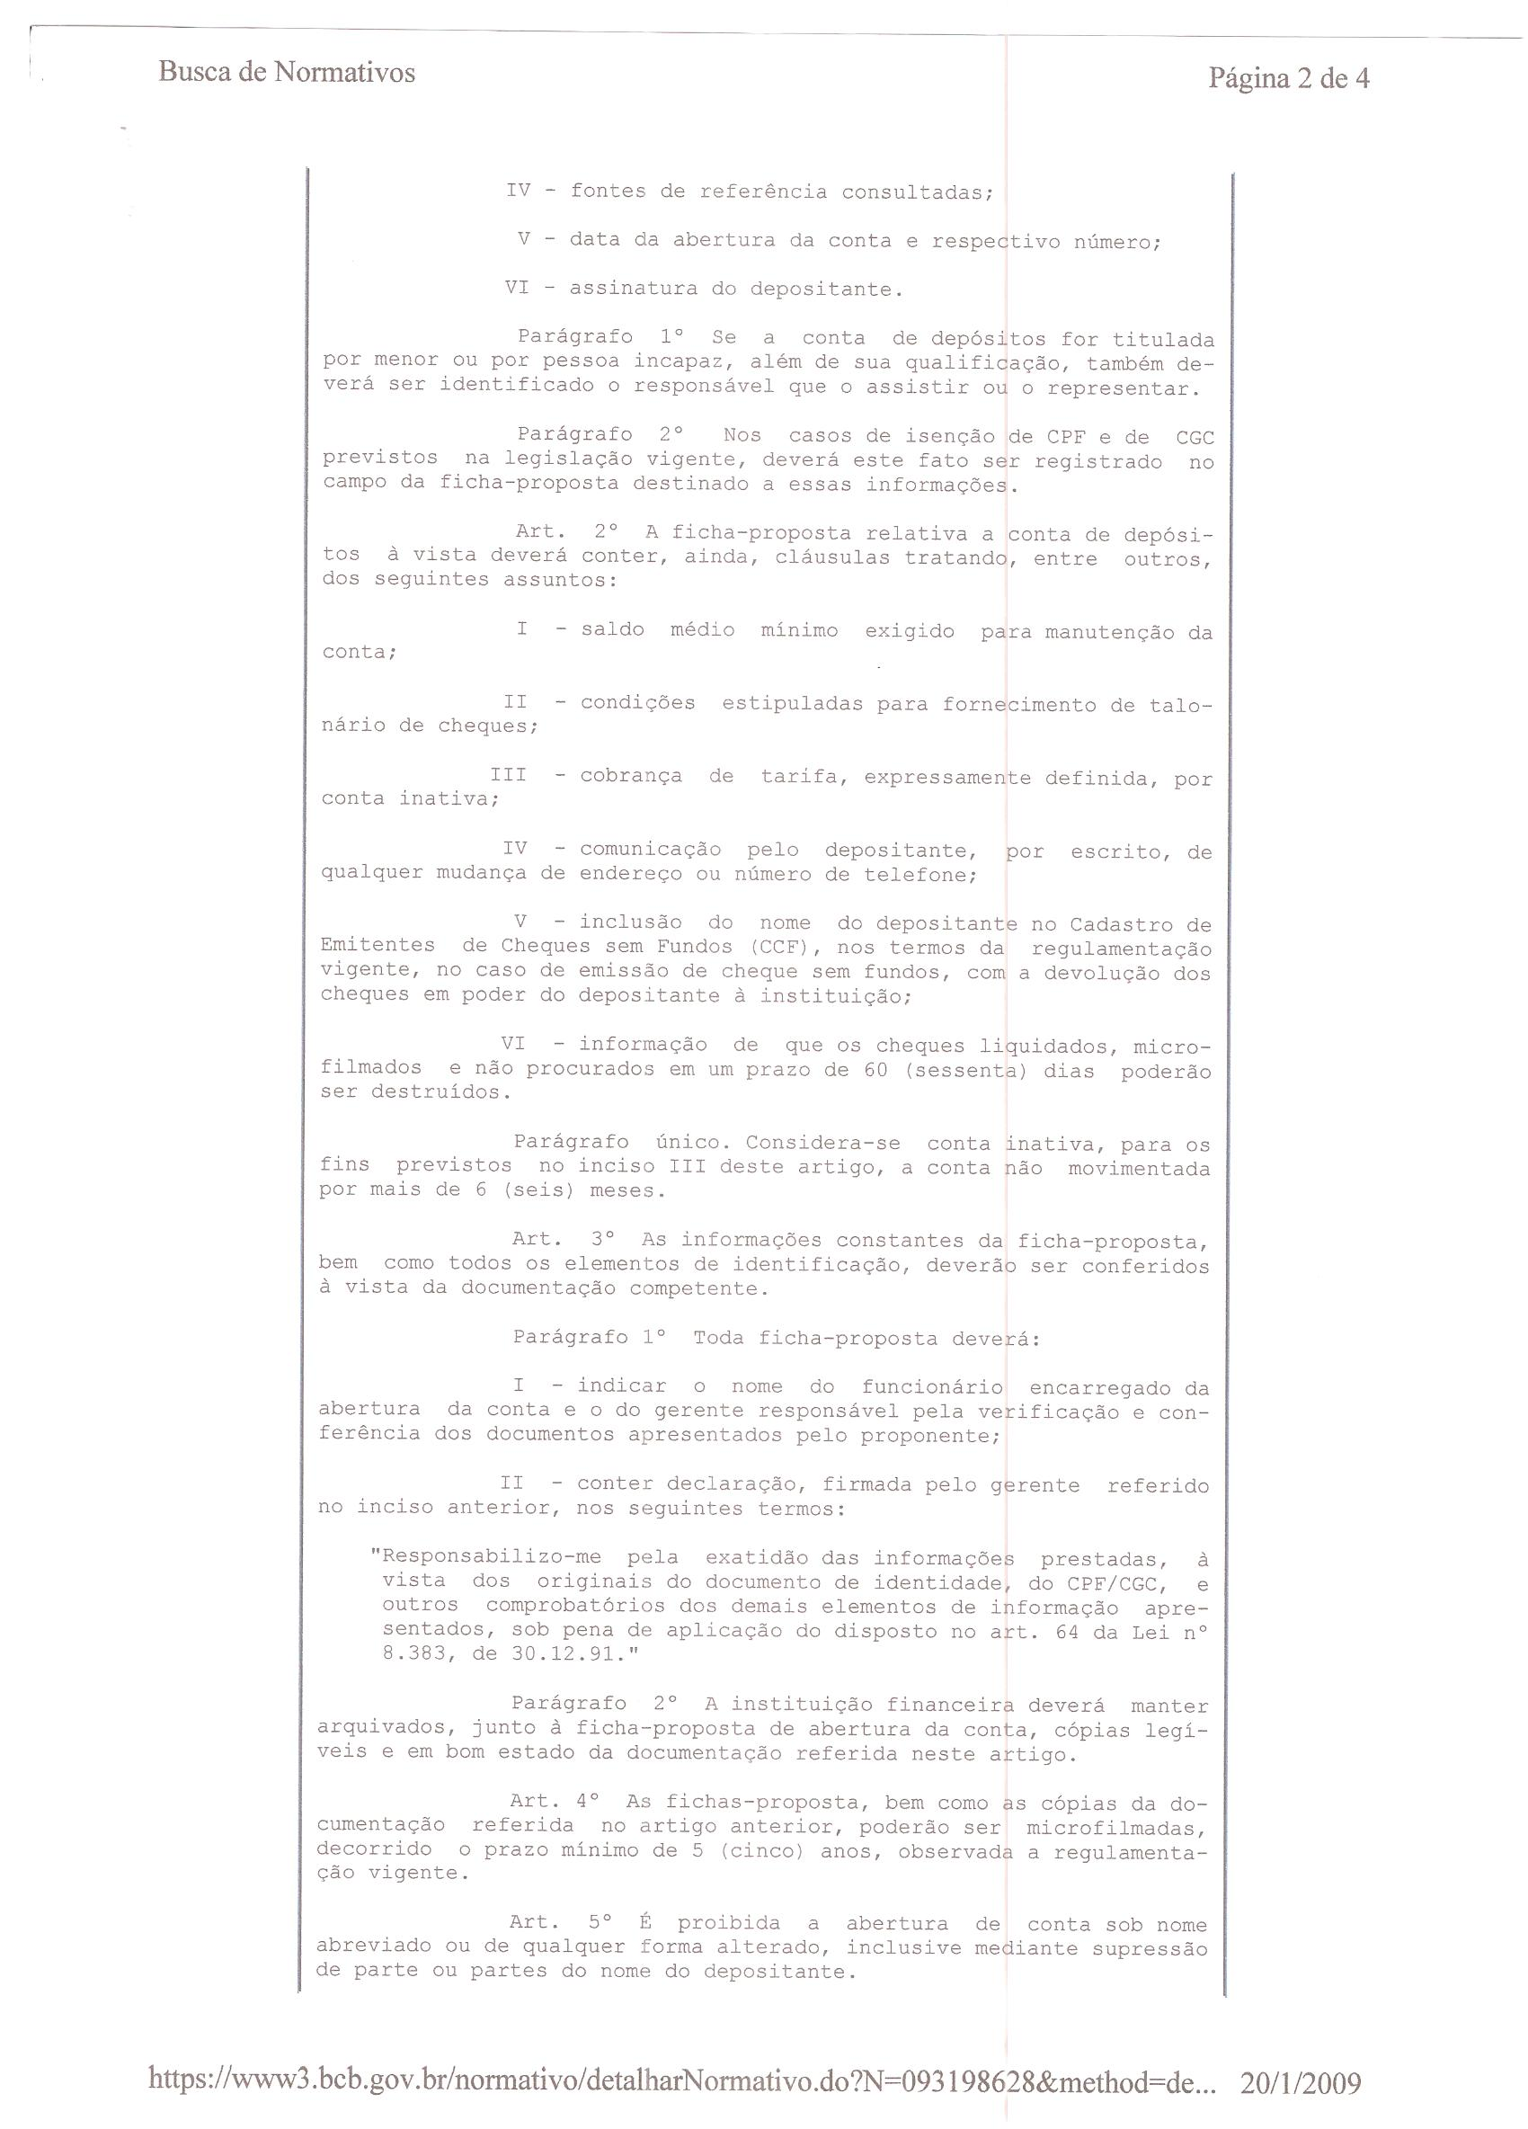

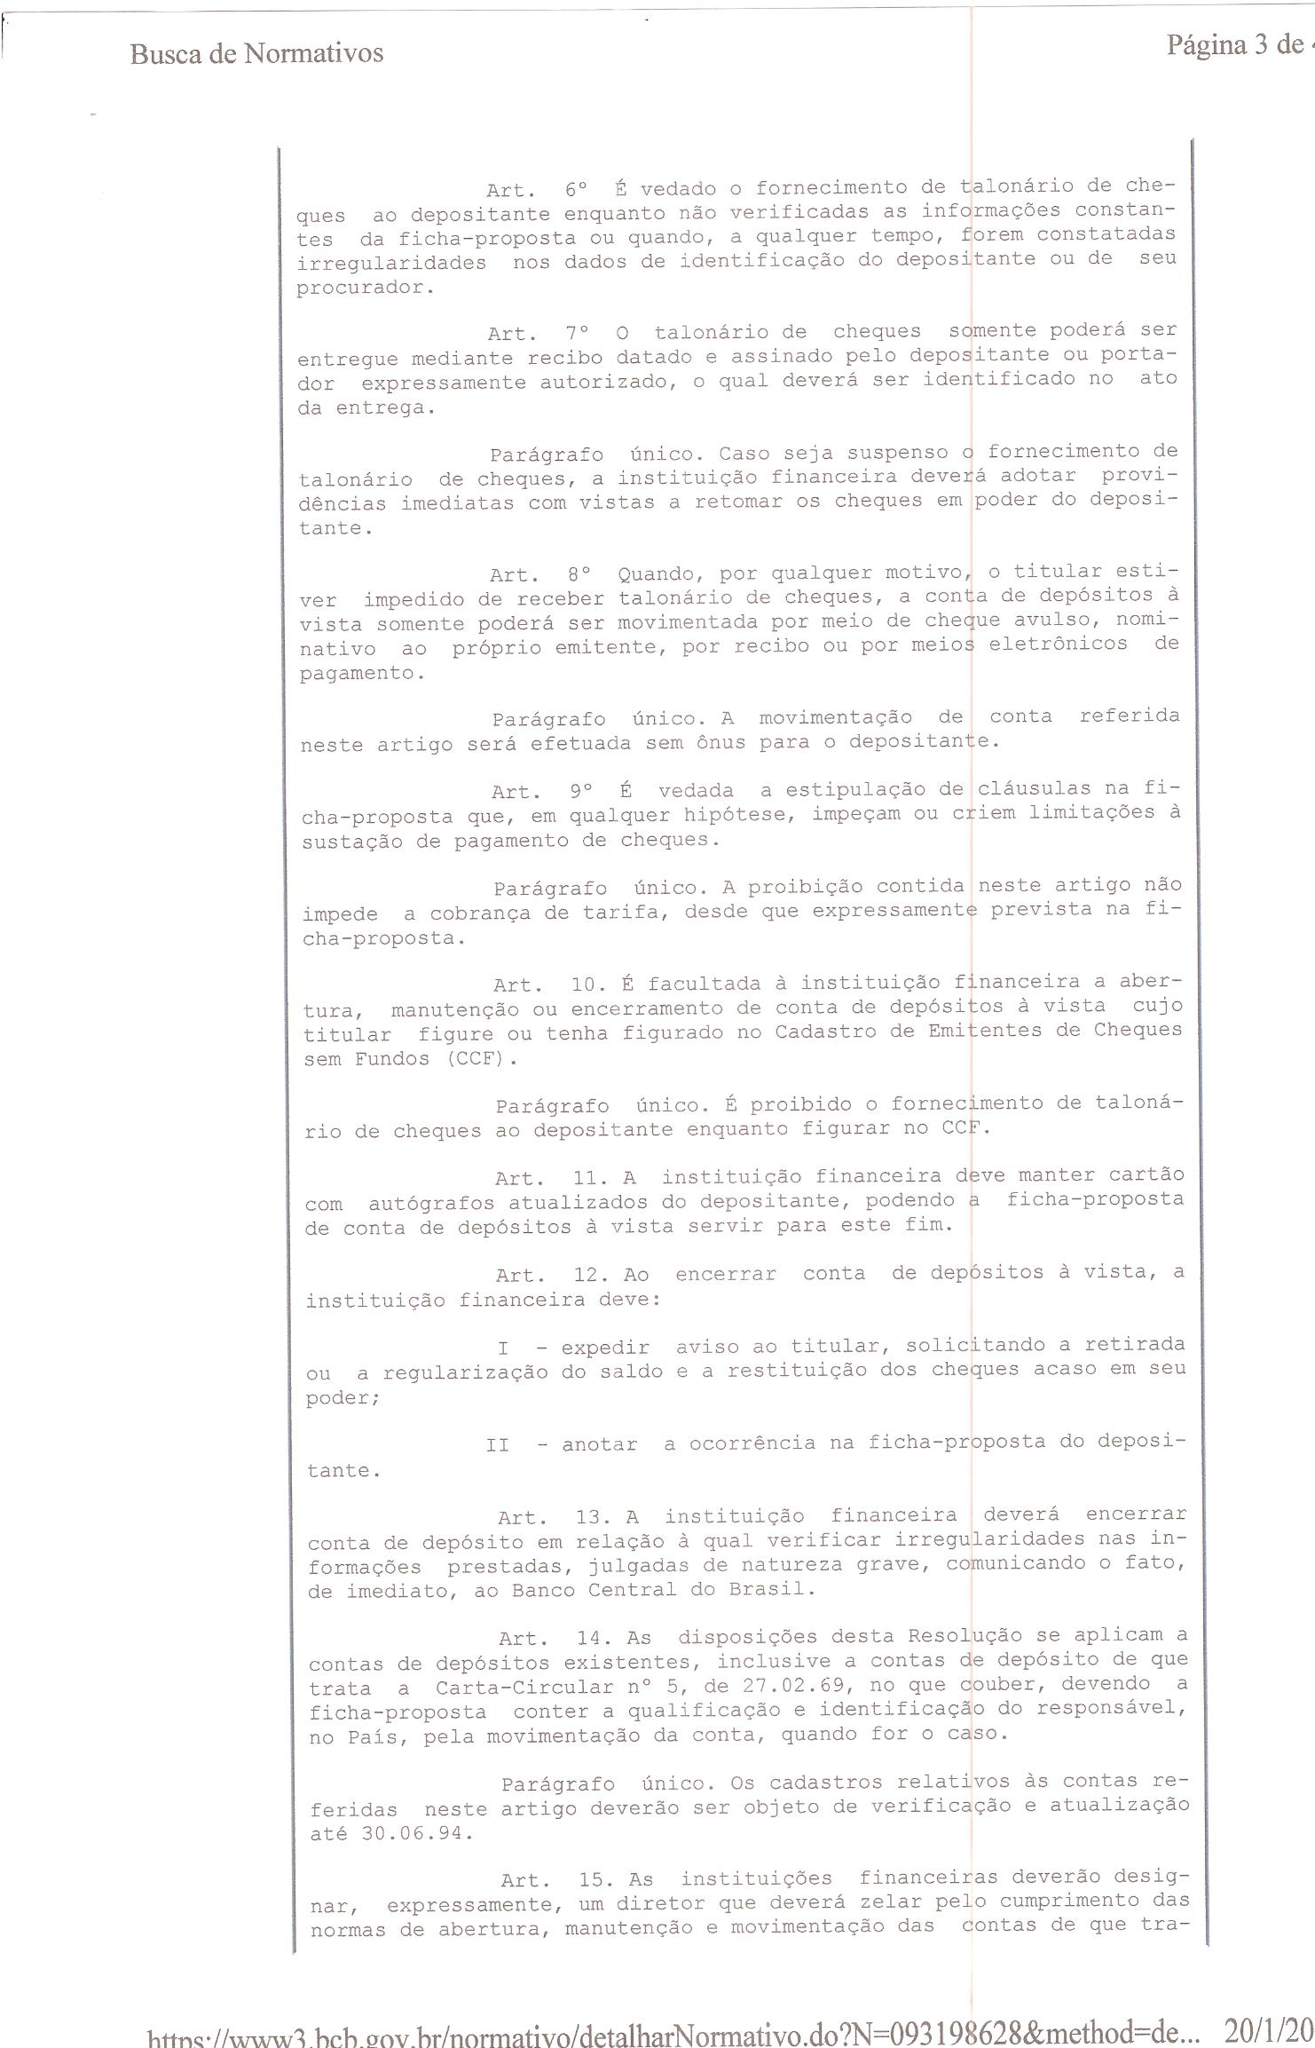

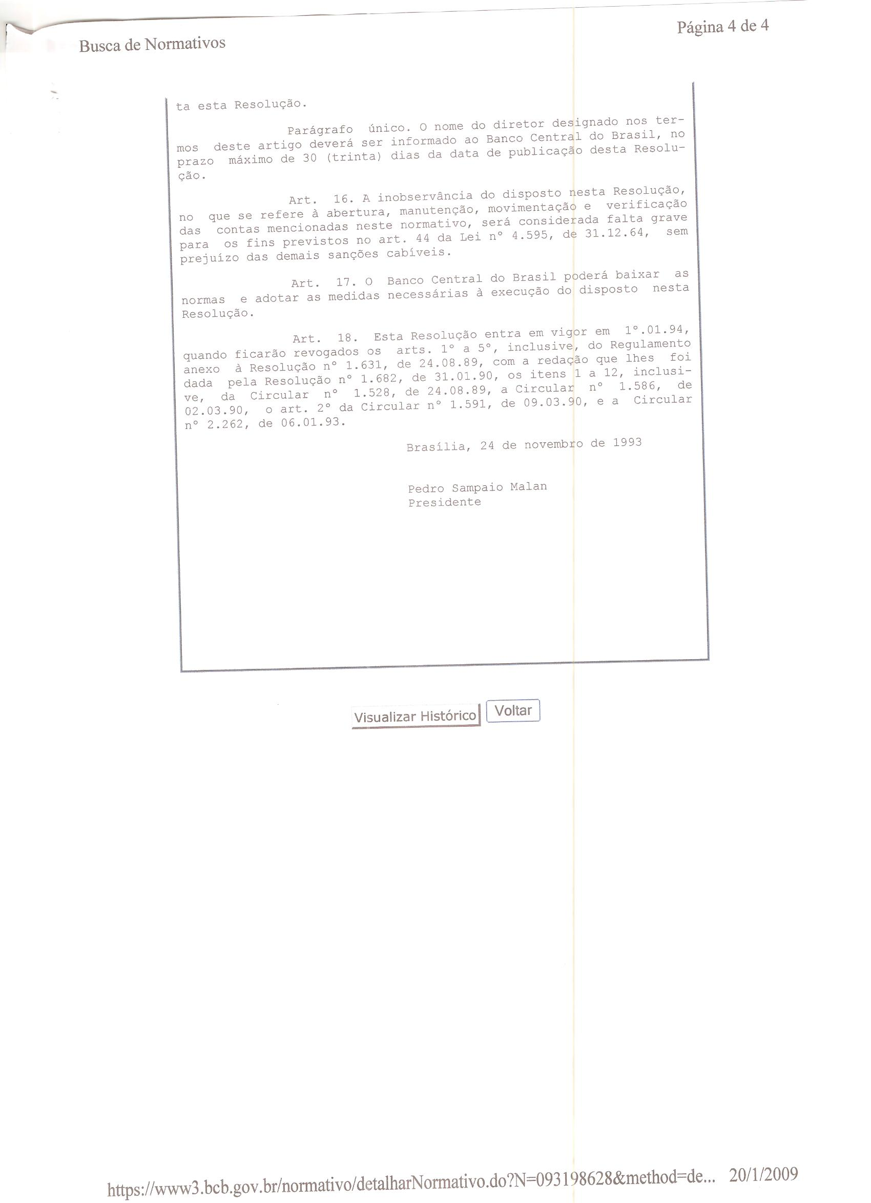

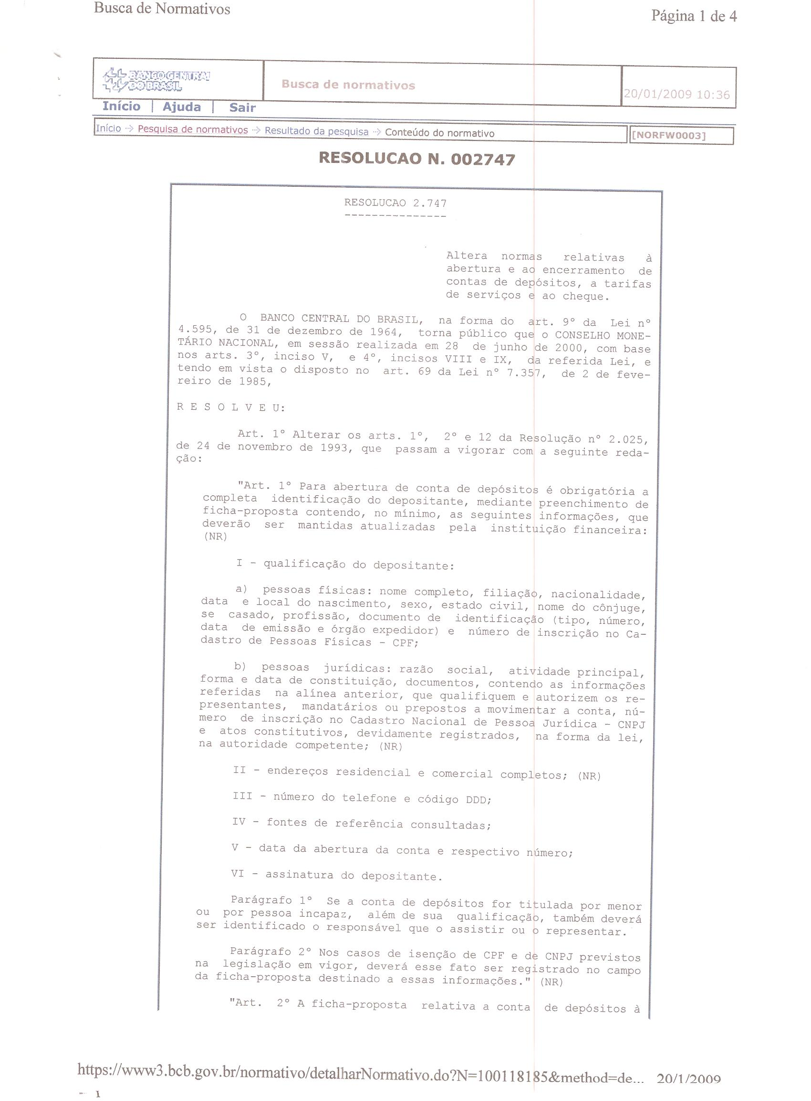

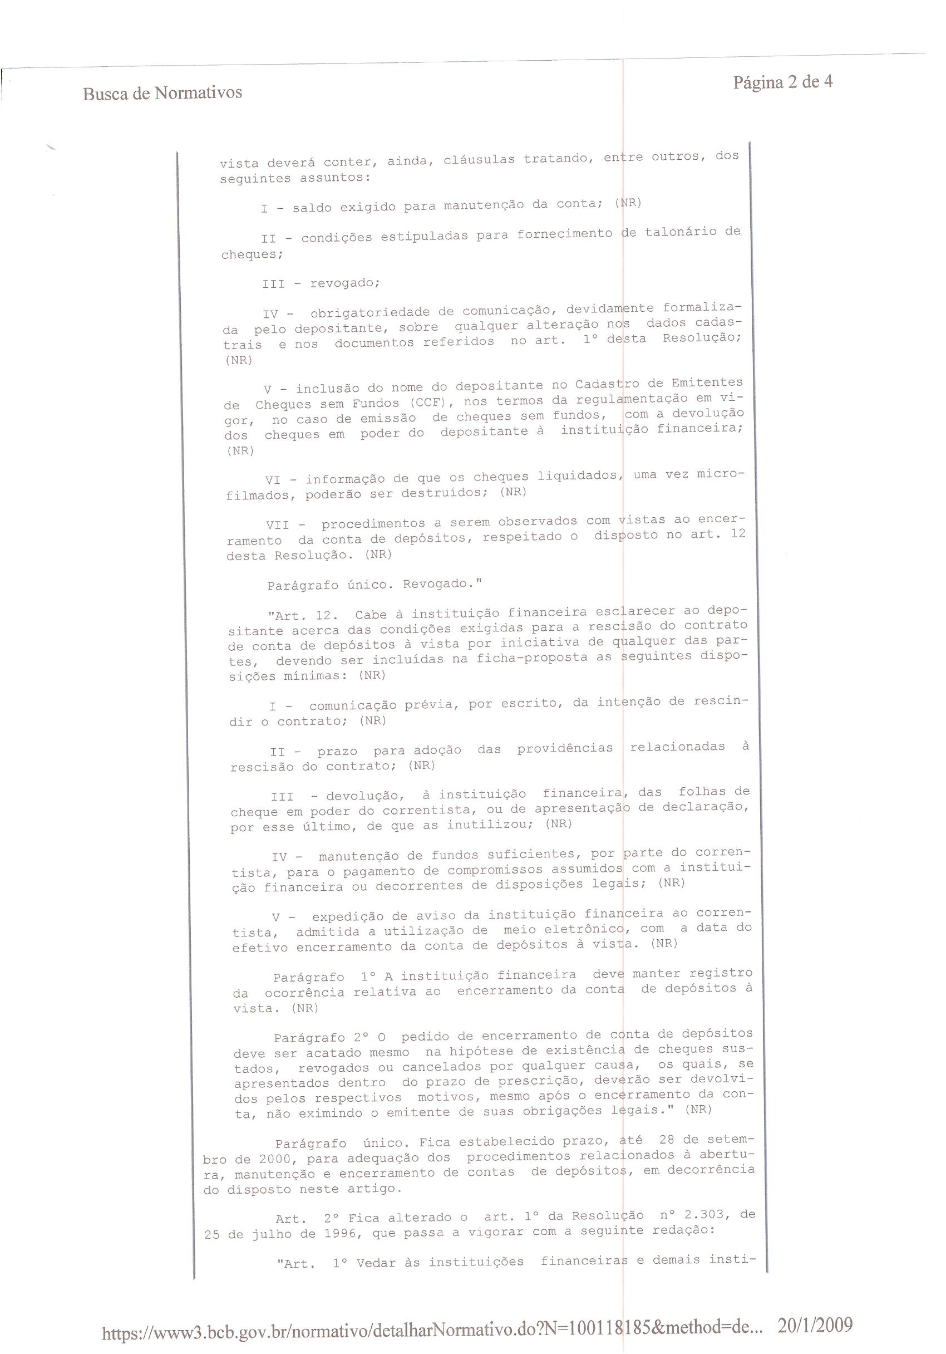

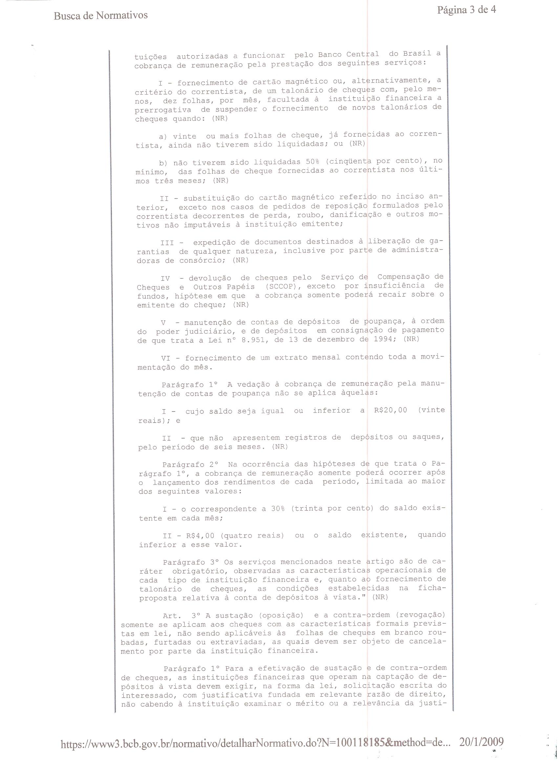

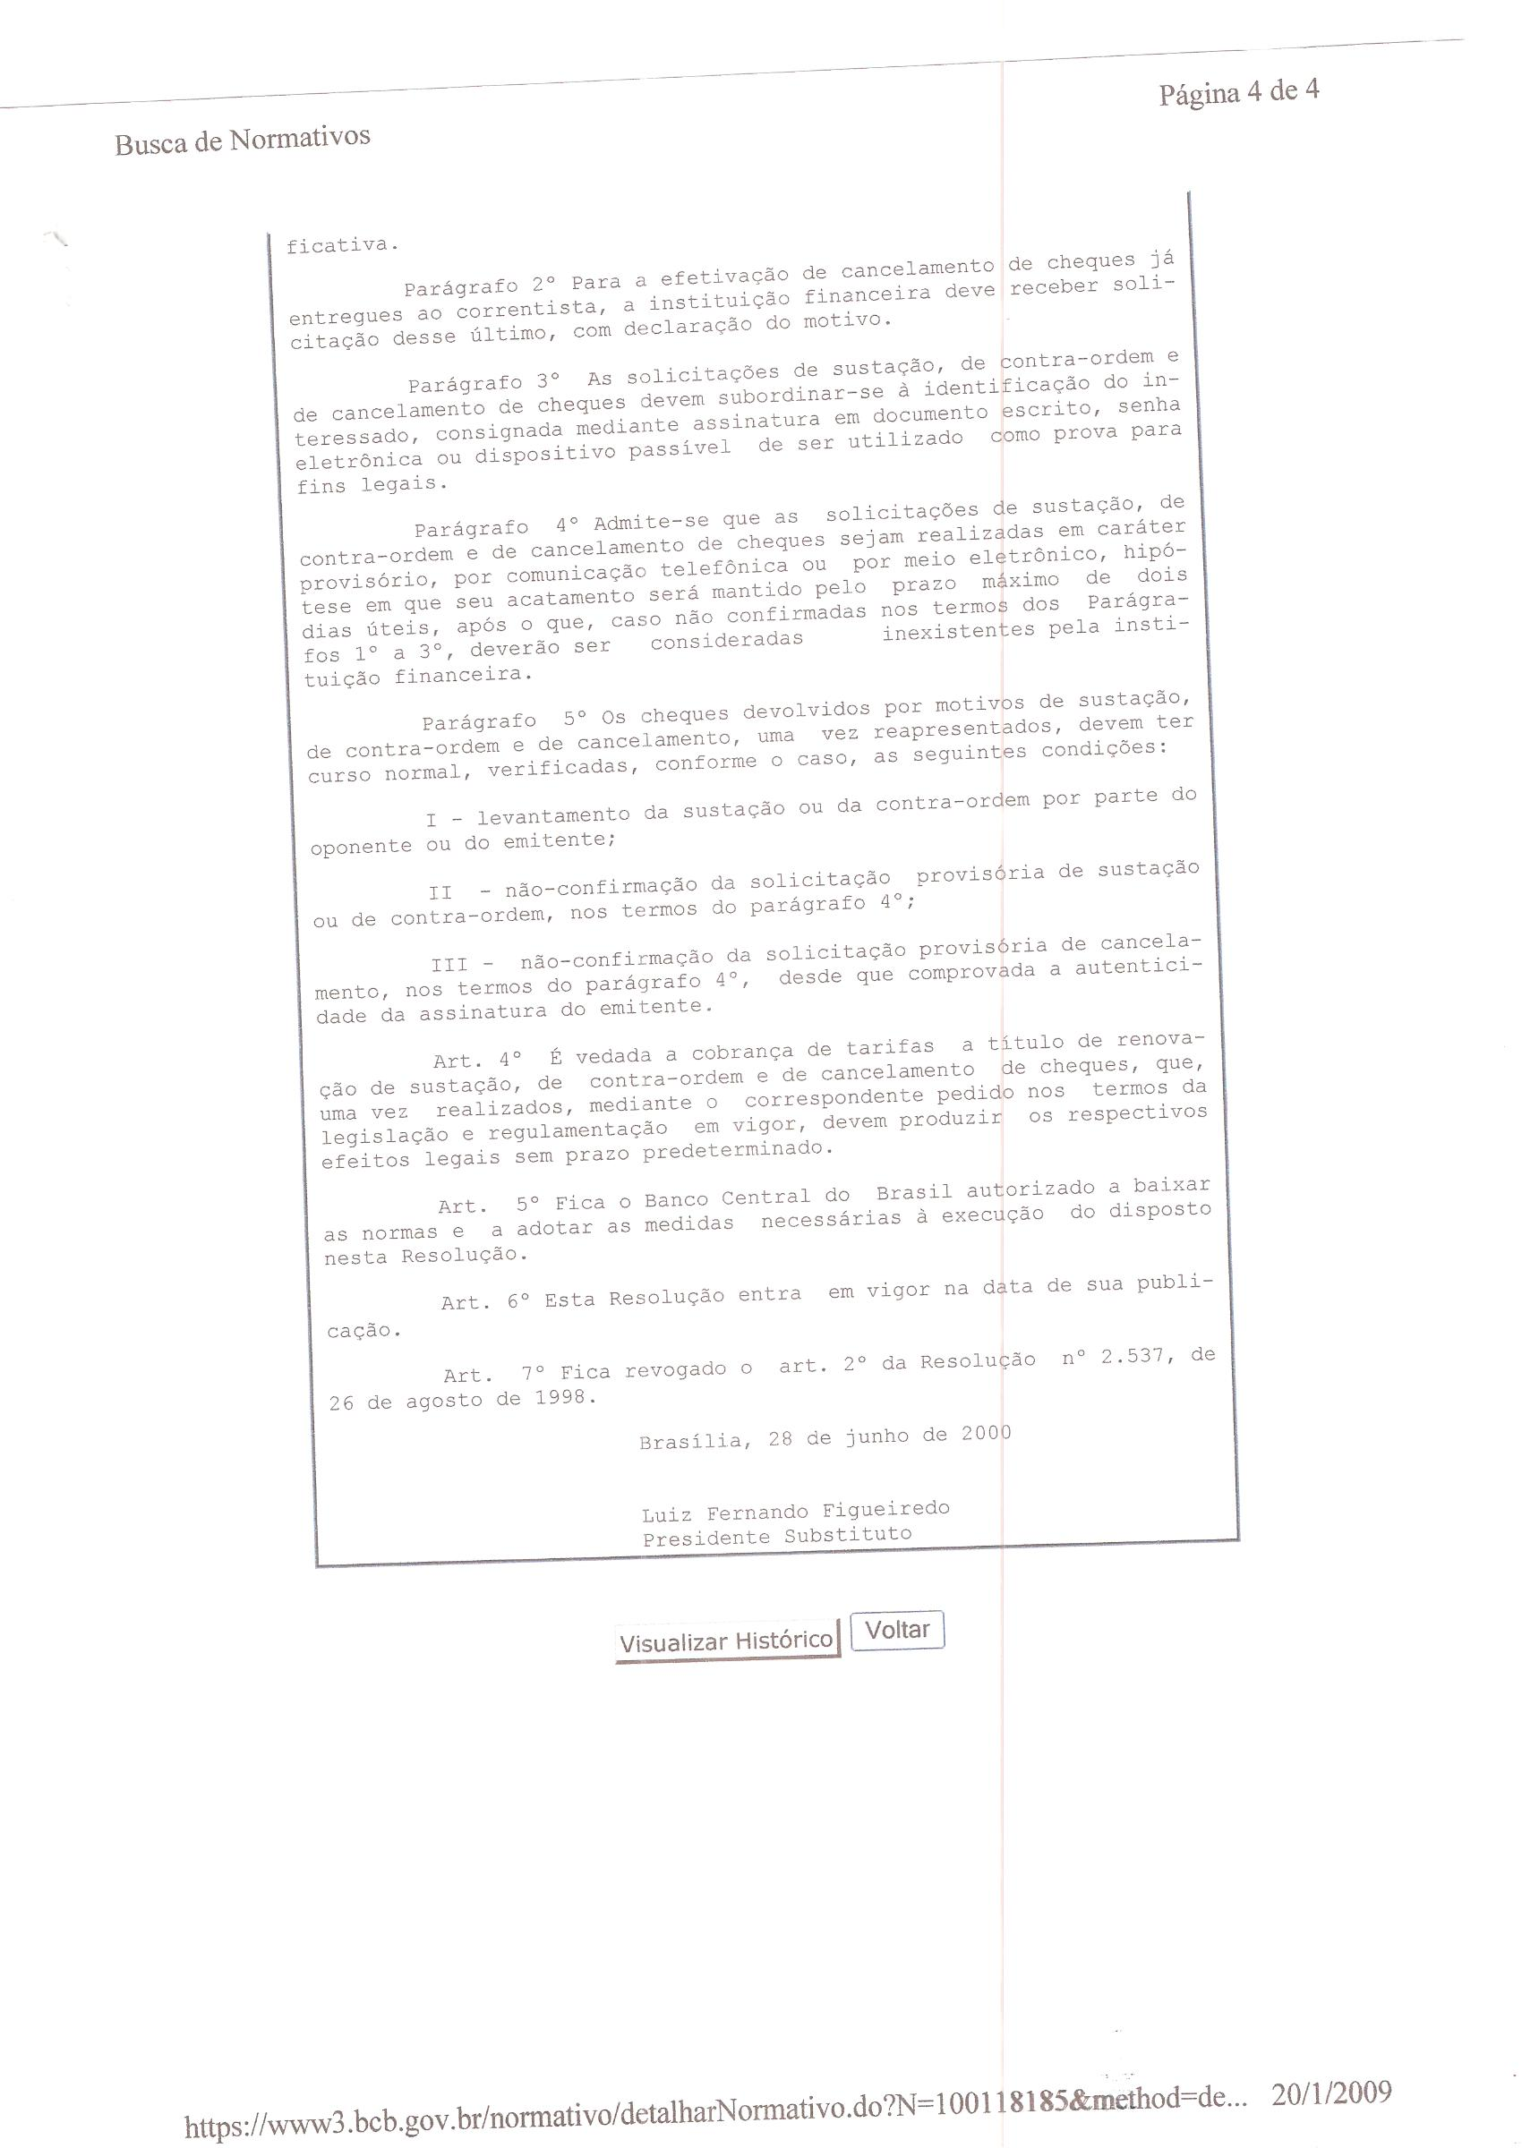

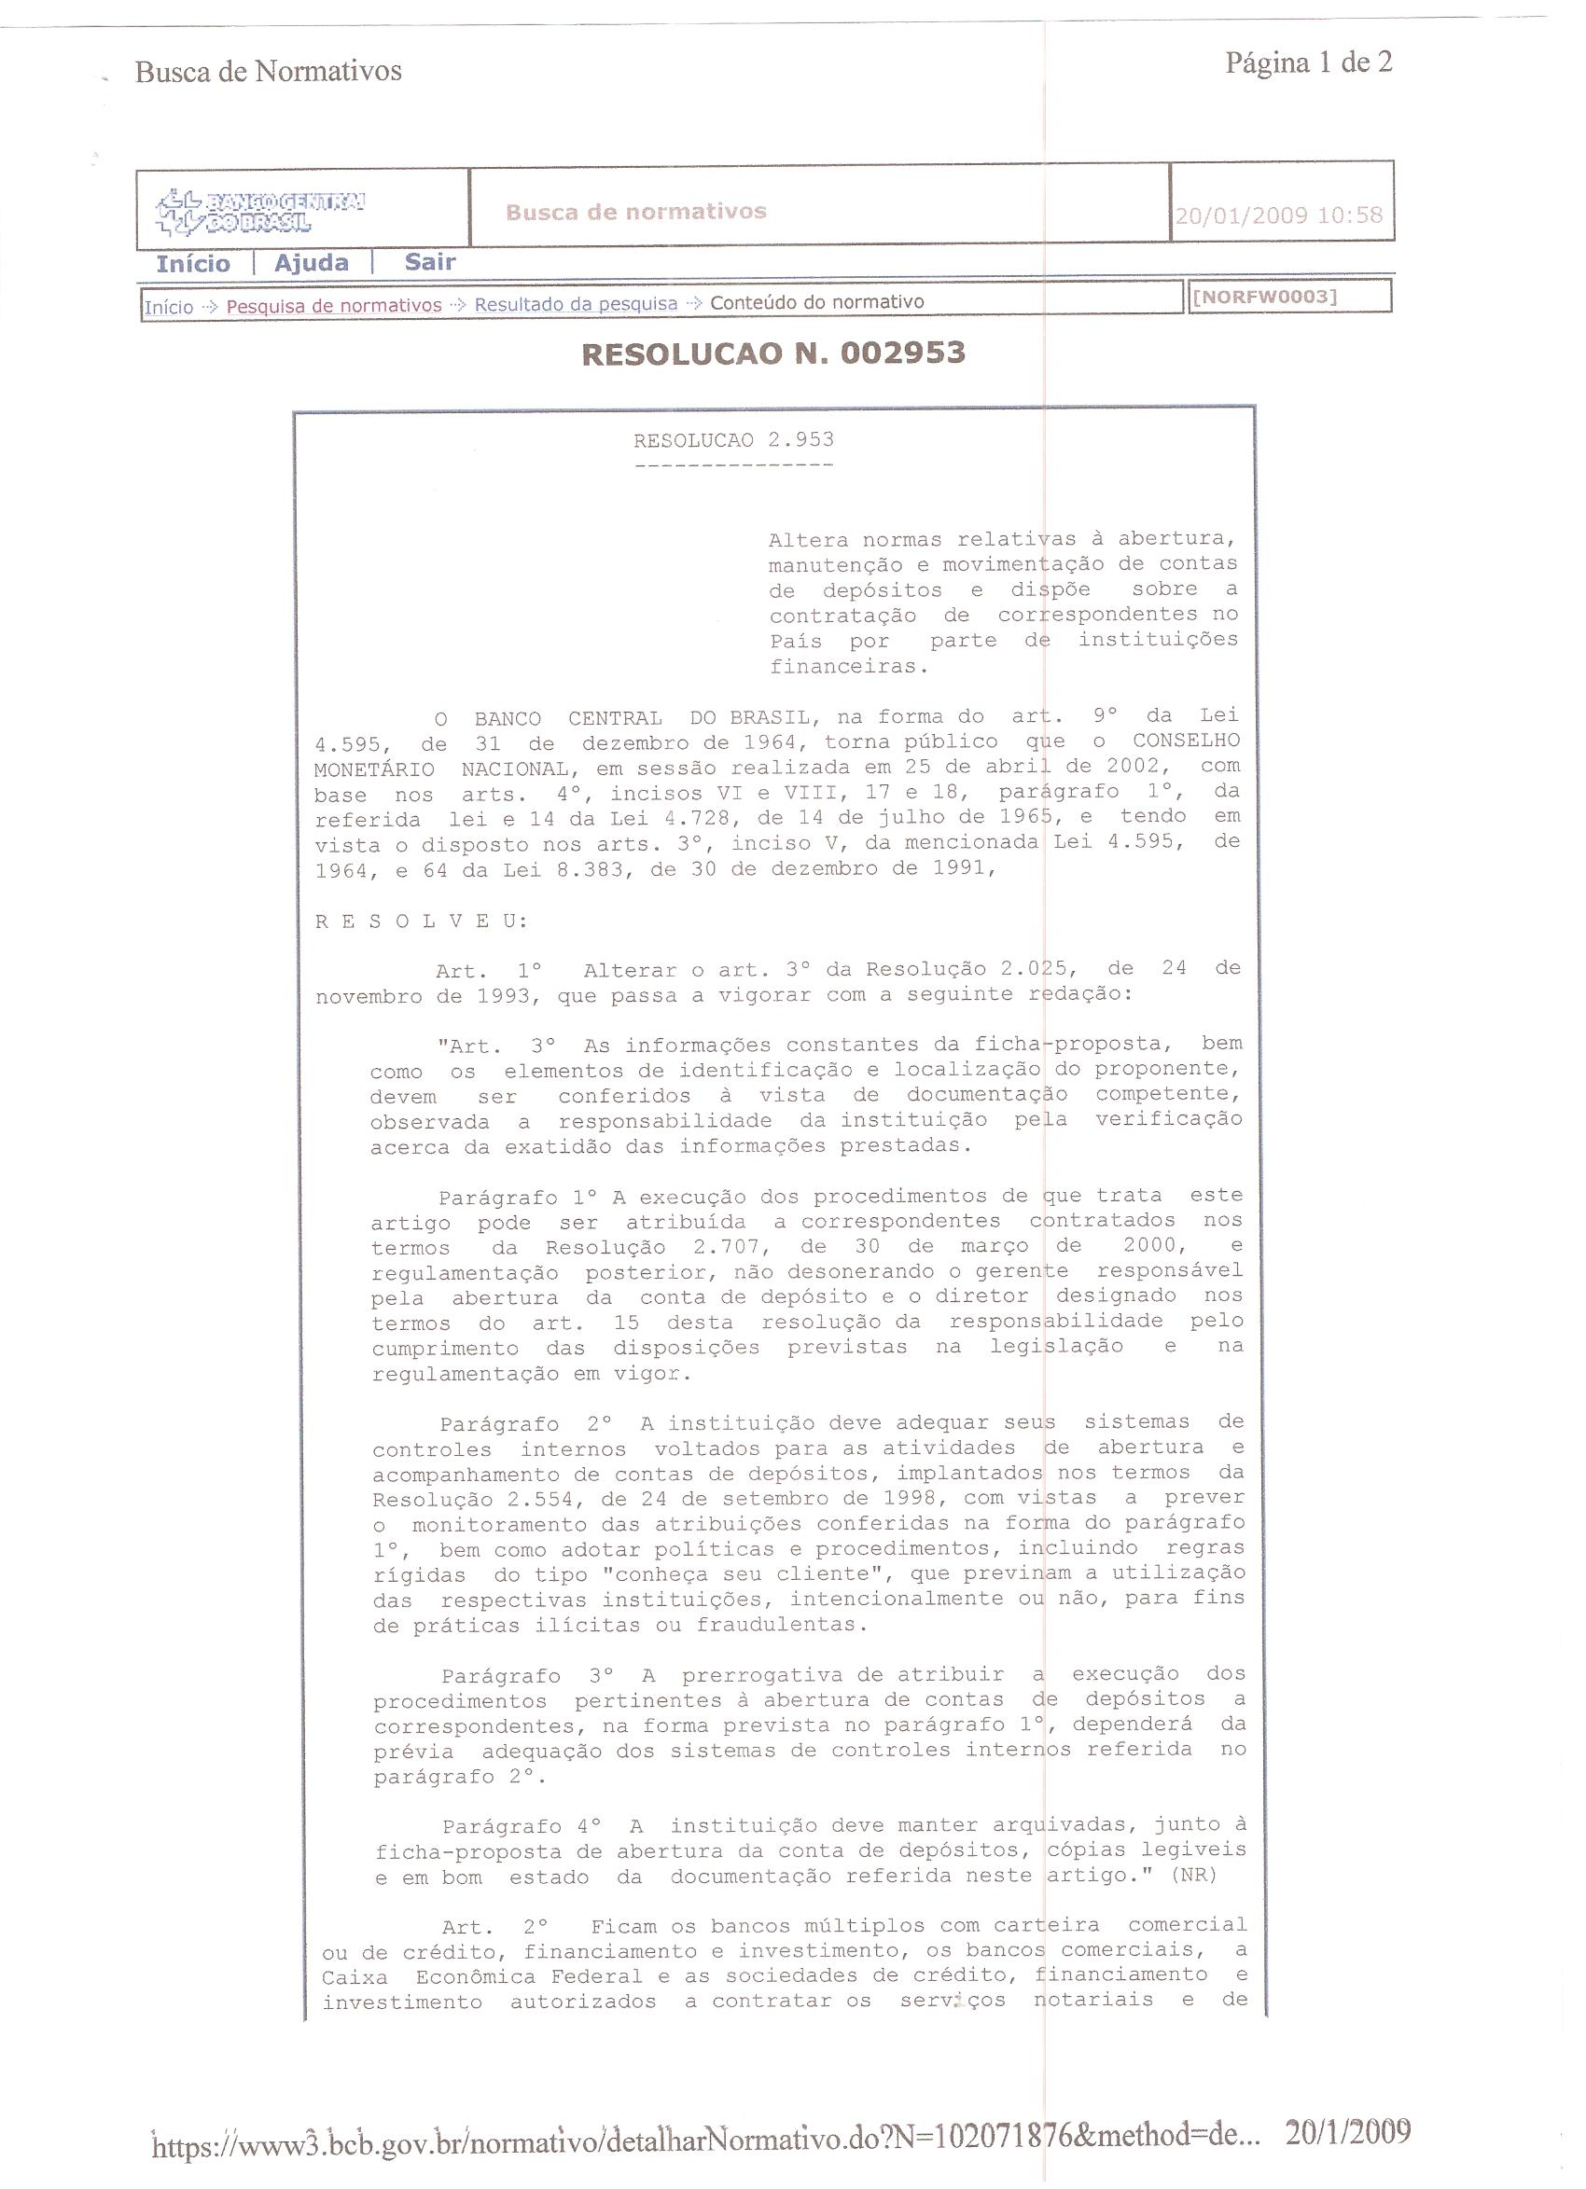

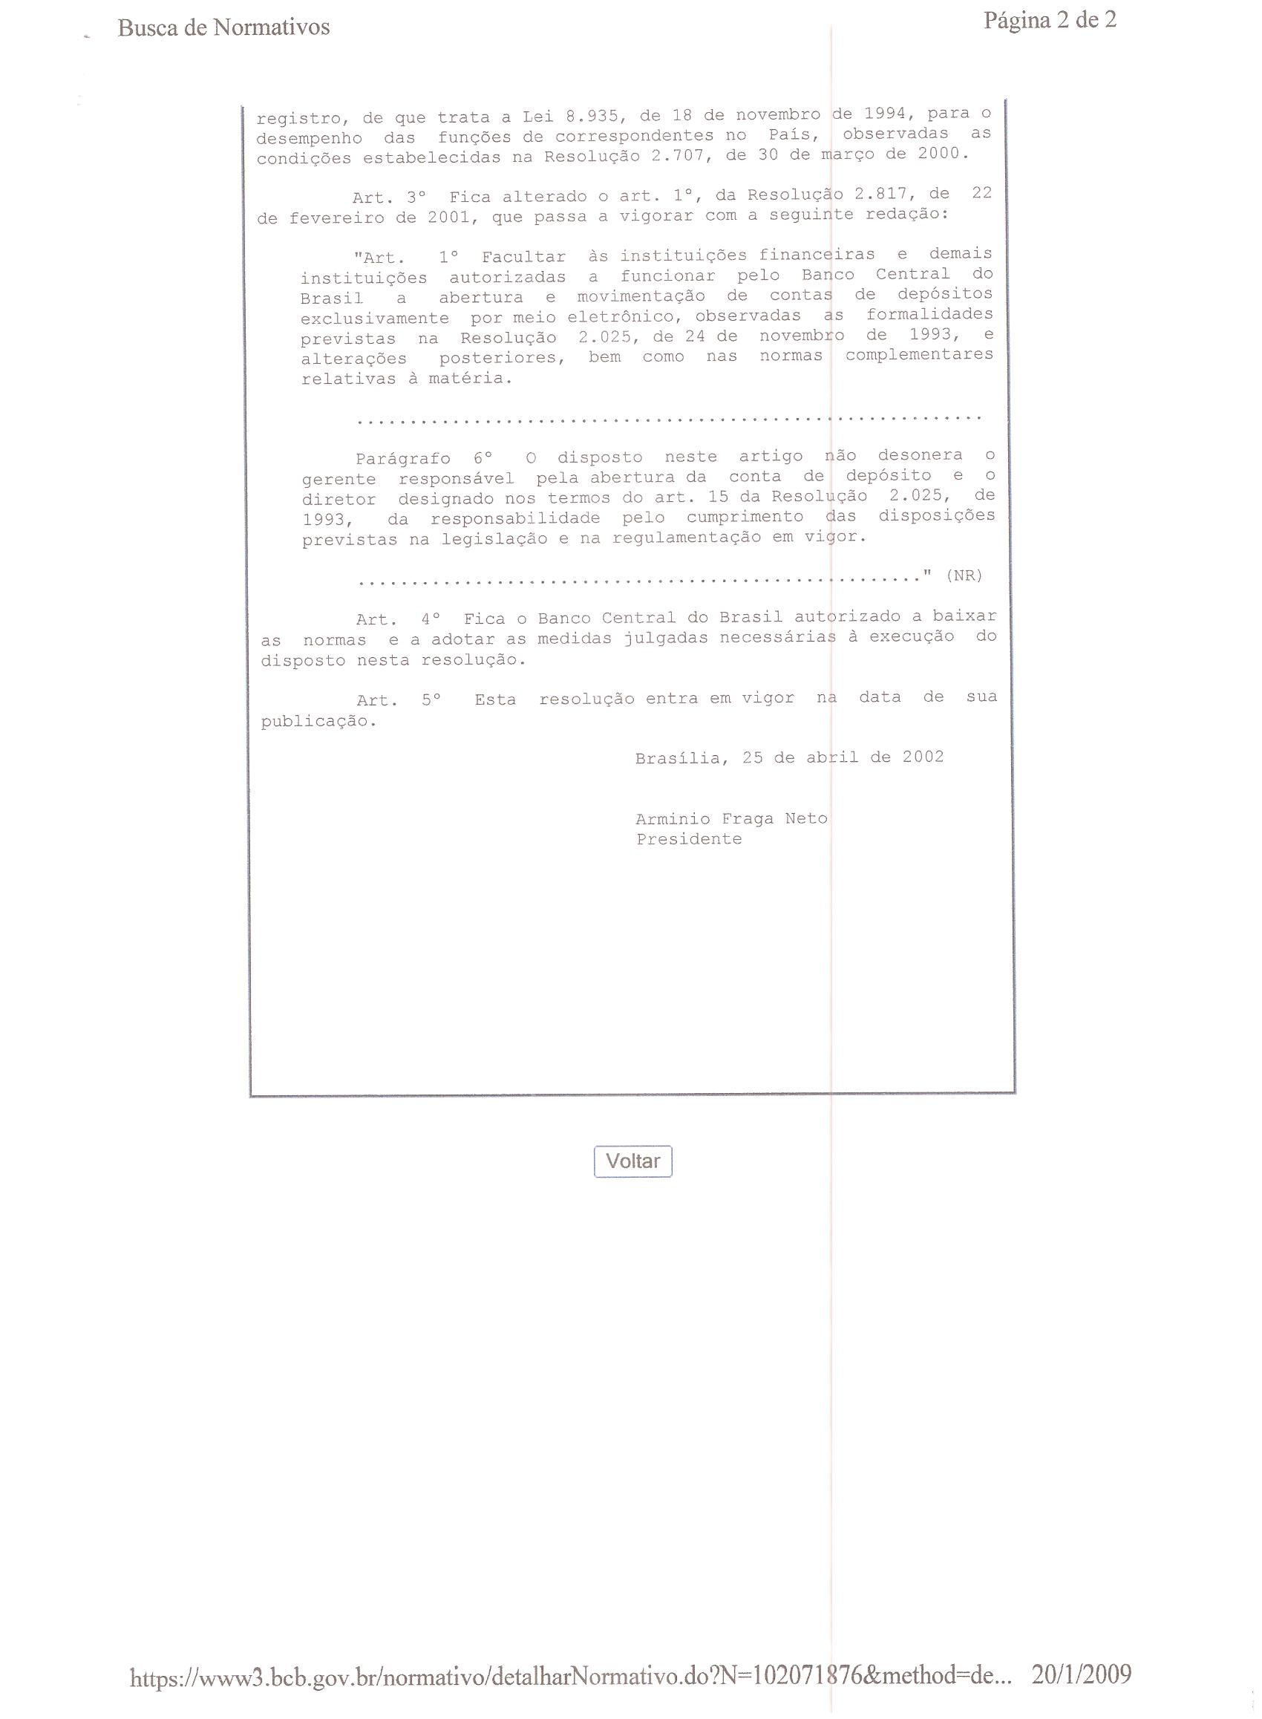

ANNEXED 2
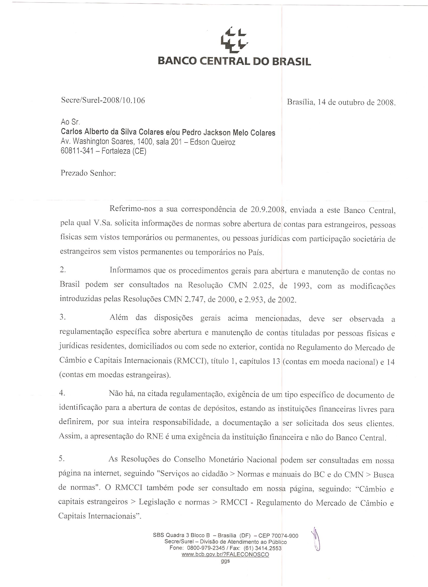

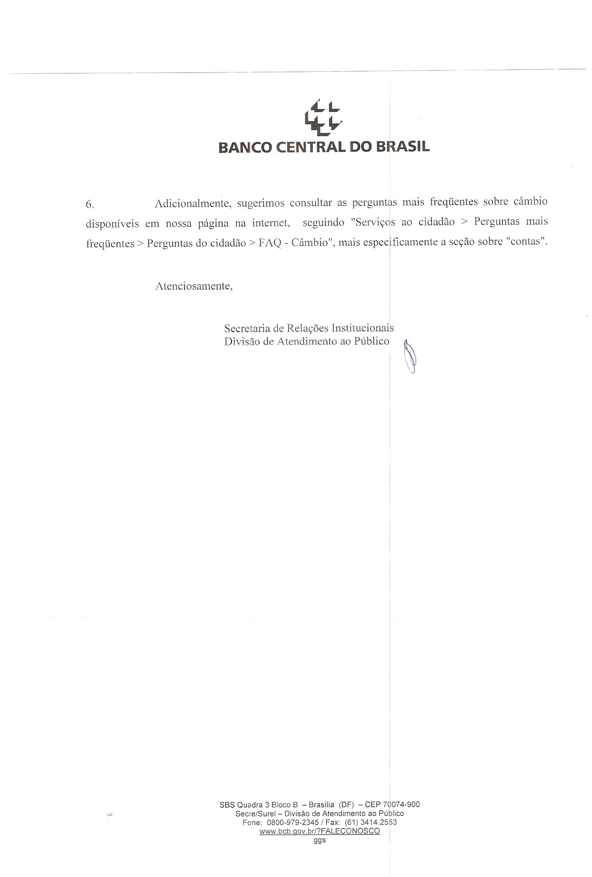

“Article 318 - the agreements of payment in gold or foreign currency are void, as well as to compensate the difference between the value of this and the national currency, except in cases provided by special legislation.”
“Article 1 - For the opening of accounts for deposits is obligatory the complete identification of the depositor upon completion of proposed-sheet containing at least the following information: I - qualifications of the depositor: a) individuals: 1. full name; 2. Parents names; 3. Nationality; 4. date and place of birth; 5. Sex; 6. marital status; 7. name of spouse, if married; 8. profession; 9. the identification document (type, number, date of issue and shipper branch); 10. Registry of Physical Person Number (CPF)."
Annexed 1.
Opinion of Central Bank of Brazil - Annexed 2.
PROPERTY Community. When a non-resident sells Brazilian real state to another non-resident the payment could take place outside Brazil. Available at: <http://www.propertycommunity.com/forum/brazil-property/4657-couple-musts-mustnots-when-investing-brazil-19.html>. Access on 23.jan.2009.
“Article 5, caput – all are equal in face of the law, without distinction of any kind, guaranteeing to the Brazilians and foreigners residents in the country the inviolability of the right to life, liberty, equality, safety and property, in the following terms […]:
“Art. 5º, incise II – nobody will be forced to do or fail to do or stop doing something else except if it provides by of law.”
“Article 2 - All human beings can claim the rights and freedoms set in the present Declaration, without any distinction, such named as race, color, sex, language, religion, political opinion or other, national or social origin, wealth, birth or other status. Furthermore, no distinction shall be made based on political, juridical or international statute of the country or territory of the naturalness of the person, even if that country or territory is independent, under supervision, autonomous or subject to any limitation of sovereignty." Available at: < http:// www.unhchr.ch / udHr / lang / por.htm>. Access on: 25.jan. 2009.
“Article 1 - Foreigners who belong to any of the Contracting States shall enjoy in the territory of the other, the same civil rights that is granted to nationals.”Par. 2 – Foreigners who belong to any of the Contracting States shall enjoy, in the territory of the other, identical individual guarantees as the citizens, except those restrictions set in each the Constitution and laws." BRASIL. Ministério das Relações Exteriores do Brasil. Divisão de Atos Internacionais. Available at: <http://www2.mre.gov.br/dai/bustamante.htm>. Access on: 25 jan. 2009.
"Article 5 – The countries have the obligation to give to foreigners residents or at passage in their territory all the individual guarantees granted to its own nationals and the enjoyment of basic civil rights." BRASIL. Ministério das Relações Exteriores do Brasil. Divisão de Atos Internacionais. Available at: <http://www2.mre.gov.br/dai/estrangeiros.htm>. Access on: 25 jan. 2009.
"Article 2 - § 2. The Member States to the present Covenant undertake to ensure that the rights set out therein is exercise without any discrimination based on race, color, sex, language, religion, political opinion or any other nature, national or social origin, economic situation, birth or other status. § 3. The developing countries, taking due account of human rights and national economic situation, can determine to which extent ensure the economic rights recognized in the present Covenant to those who are not their nationals." SÃO PAULO. Biblioteca Virtual de Direitos Humanos da Universidade de São Paulo. Available at: <http://www.direitoshumanos.usp.br/counter/Onu/Sist_glob_trat/texto/texto_2.html>. Access on: 25 jan. 2009.
"Article 2 - 1. Each of the Signatories-States to the present Covenant undertakes to respect and ensure to all individuals who are within its territory and subject to their jurisdiction the rights recognized in the present Covenant, without distinction of any race, color, sex, language, religion, political opinion or other nature, national or social origin, economic position, birth or any other social condition." "Article 26 - All people are equal in the face of the law and are entitled without discrimination to equal protection of law. About this respect, the law shall prohibit any discrimination and guarantee to all people equal and effective protection against discrimination on grounds of race, color, sex, language, religion, political or other opinion, national or social origin, economic position, birth or any other social condition." CIDADE VIRTUAL. REFWORLD Instrumentos Internacionais. Available at: <http://www.cidadevirtual.pt/acnur/refworld/refworld/legal/instrume/detent/civpot_p.htm>. Access on: 25 jan. 2009.
"Article 1 - 1. The States Partners to this Convention undertake to respect the rights and freedoms recognized therein and to ensure their free and full exercise to every person who is subject to its jurisdiction, without any discrimination on grounds of race, color, sex, language, religion, political opinion or any other nature, national or social origin, economic position, birth or any other social condition. " SÃO PAULO. Procuradoria Geral do Estado de São Paulo. Tratado Internacional. Available at: <http://www.pge.sp.gov.br/centrodeestudos/bibliotecavirtual/instrumentos/sanjose.htm>. Access on: 25 jan. 2009.
SPAIN BUSSINESS. Normas sobre Controle de Câmbio. Available at: <http://www.spainbusiness.pt/icex/cda/controller/pageInvBrasil/0,5274,31361682_32227355_38103284_0,00.html>. Access on: 20 jan. 2009.
PORTAL ESPAÑOL DE MOVILIDAD PARA INVESTIGADORES. Guia Práctica para Investigadores Extranjeros em España. Available at: <http://www.eracareers.es/fecyt/guia2008/cap15.jsp>. Access on: 22 jan. 2009.
MY SWISS ADVISER. Abertura por Correspondência de Conta Bancária na Suíça. Disponível em: <http://www.myswissadviser.com/pt/mandat_PRO.htm>. Access on: 21 jan. 2009.
POUPANÇA Bancária e Remessa. Guia de Estrangeiro. Available at: <http://www.ia-ibaraki.or.jp/kokusai/portugal/life/guide/03-03.html>. Access on: 21 jan. 2009.
"Article 22 of Law 7492/86 - Make unauthorized exchange transaction in order to promote escaping of foreign currency of the country: Penalty - imprisonment of two (2) to 6 (six) years and fine. Single paragraph. Incurs the same penalty who, in any capacity, promote, without legal authorization, the removal of coin or currency to the outside, or it remain deposits not declared to the federal jurisdiction competent. "

